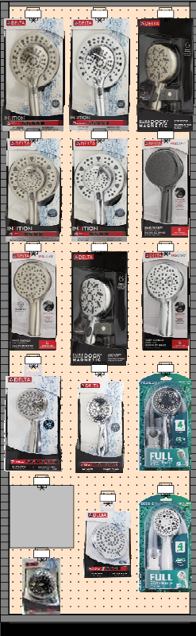

* Regular Cost: $973.17 Special Cost : $631.17
* 2% 120 days dating
* 11 new RSC items
* Variety of finishes – Chrome, Brushed Nickel, Matte Black
* Larger Spray faces
* Innovative features – In2ition, SureDock, Pro Clean
* Top Retail Price Ranges by Category

**35% discount Save $342**

**40-600 – 2’ CS Showerheads Delta & Peerless**

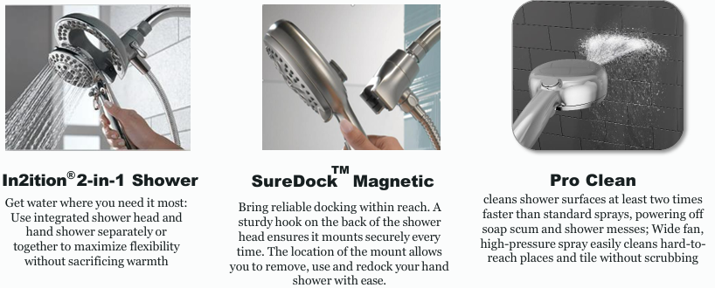

**To order go to mydoitbest.com/Product News/Category Solutions**